
Ghorxata 1.0

Debugger output
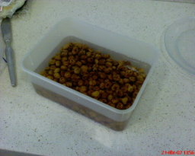image 1 | 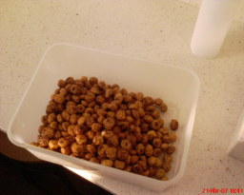image 2 | 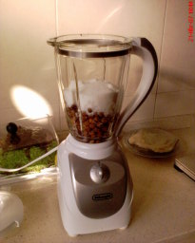image 3 | 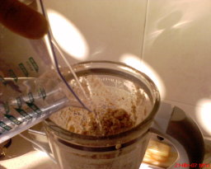image 4 | 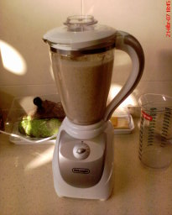image 5
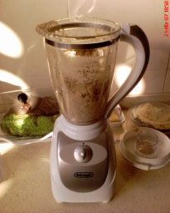  image 6 | 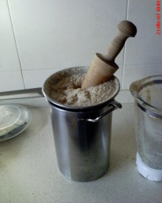image 7 | 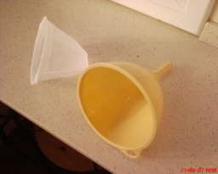image 8 | 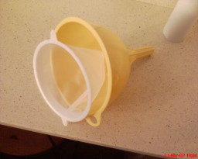image 9 | 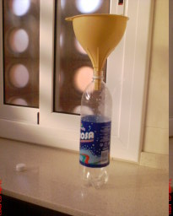image 10
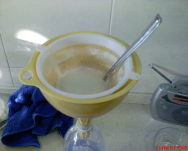image 11 | 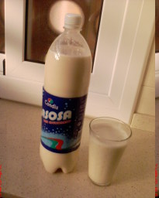image 12

Codi font

***************************************************************************
* *
* Ghorxata 1.0 - valid khorxata conversion *
* *
* At sumer controls computer user temperature *
* *
* Copyright (C) 2007 by Carles Oriol,,, *
* carles@kumbaworld.com *
* for l'equip d'ubuntaires en català. http://www.ubuntu.cat *
* Ubuntu CatalanLoco Team *
* *
* Translated into english on may 6 2007 by Carles Oriol *
* *
* This program is free software; you can redistribute it and/or modify *
* it under the terms of the GNU General Public License as published by *
* the Free Software Foundation; version 2 or later *
* *
***************************************************************************/

#include <math.h>

#include <vertical_mixer.h>
#include <balanca.h>
#include <mesures.h>
#include <strainer_xines.h>
#include <bottle.h>
#include <permanent_coffe_filter.h>
#include <container.h>
#include <ingredients.h>
#include <funnel.h>

#include <chronomether.h>

#define QUANTITY 100
#define QUANTITY_water_mixer_1pass_capacity 300

void main ()
{
// ghorxata object creation test;
// Carles Oriol 21/06/2007

const int QUANTITY_water = QUANTITY * 6;

// Build needed objects
vertical_mixer mixer = new vertical_mixer ( SIZE_mixer );
strainer_xines strainer = new strainer_xines ();
container_strainer = new container ( QUANTITY * 8 );
// Alloc at container enough space to collect maximum ingredients to add
// and we'll have space left.

// Link strainer to container to obtain the output
strainer.link( container );

// Mixel moduel will destroy all the objects inserted in.
// It's important to put chufas in water for 12h but it's optional.

mixer << ( new ingredients_chufas ( QUANTITY ) ); // image 1 i 2
mixer << ( new ingredients_sugar ( QUANTITY ) );

// image 3

int QUANTITY_done = 0;

// We'll repeat until we end the watter

while ( QUANTITY_done < QUANTITY * 6 )
{
int QUANTITY_to_do_this_pass = min( QUANTITY_water_mixer_1pass_capacity,
(QUANTITY * 6) - QUANTITY_done );

mixer << ( new ingredients_water ( QUANTITY_to_do_this_pass ) ); // image 4
mixer.Speed( 3 ); // Speed range from 1 to 3
mixer.Run (); // image 5

chronomether.sleep ( 60 * 3 ); // in seconds

mixer.Stop ();

strainer << ( mixer.Resultat() );

strainer.use(); // image 6

// Stainer buffer will remain betwen passes

// we move stainer left to the mixer and we'll mix with water again
mixer << ( strainer.left() );

QUANTITY_done += QUANTITY_to_do_this_pass;
}

// Ready objects for the last filter.

// image 8
big_funnel funnel = new big_funnel( );
Permanent_coffee_filter filter = new Permanent_coffee_filter();
usedsodabottle bottle = new usedsodabottle();

funnel.link( filter ); // image 9 - Link filter to funnel and the output to the bottle
funnel.link( bottle );

// Warning. In this process we have simplified this part assuming the bottle capacity
// it's enough for the total result.
// Can happen a non recoverable stack overflow if not controlled from the start
// and that would need a sophisticated cleaning kitchen process.
// must be revised before version 1.1

// We add the content of container to the funnel to fine filter and load the object bottle.
funnel << ( container.Resultat() ); // image 10 i image 11

// We have the object ghorxata ready at bottle.Content();
// You just have to fridge it for 24h before use

fridge myfridge = new fridge( );
myfridge.add( bottle );

chronomether.sleep ( 60 * 60 * 24 );

myfridge.remove( bottle );

// and ... blaaam!!! We can use ghorxata now!!

// horxata = bottle.Content(); !!!!!!!!!!!!!!!!!!!!!!!!!!!!!!!!!!!!!!!!!!!!!!!!!!!

// Object destroyers have a cleaning process

}

Translation notes: Horxata is a typical soft dring in the catalan countries done with chufa. It's a typical refresh on summer times. This recipe is correct and the results shown at top are real. You just have to read the code to do it.

