Ubuntu Drupal

Setup Guide: UD Countdown

Table of Contents
Installation 3
Configuration 5
Configure the Block 7
Permissions 8

Installation
To install the module, I will assume you already followed the UD Theme installation guide. From the front page click “Administer.”

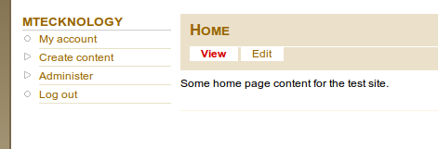

In the “Site Building” section click “Modules.”

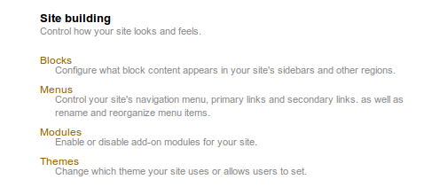

You will then be looking at the modules page.

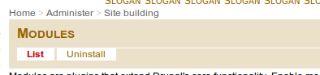

Scroll down to the bottom of the page to see the “Ubuntu Drupal” group of modules.

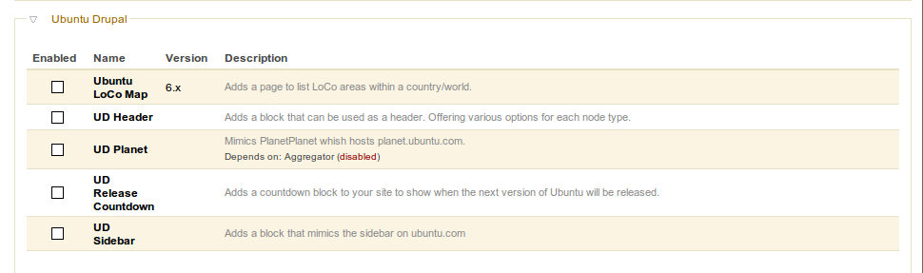

Select the “UD Release Countdown” module and click “Save Configuration.”

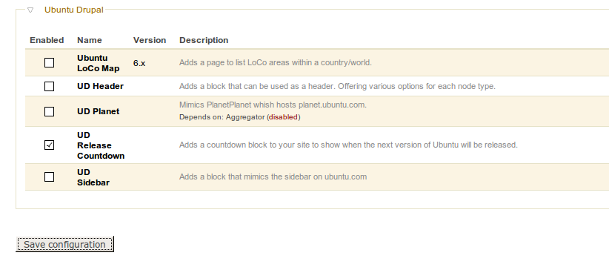

Configuration
Go to the “Administration” page.

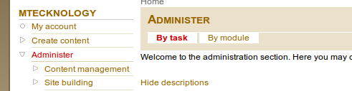

Click the “UD Countdown Settings” link.

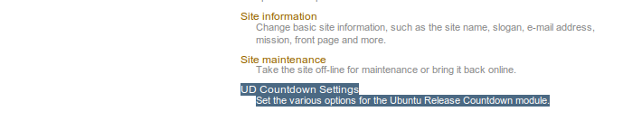
You will now see the available settings.

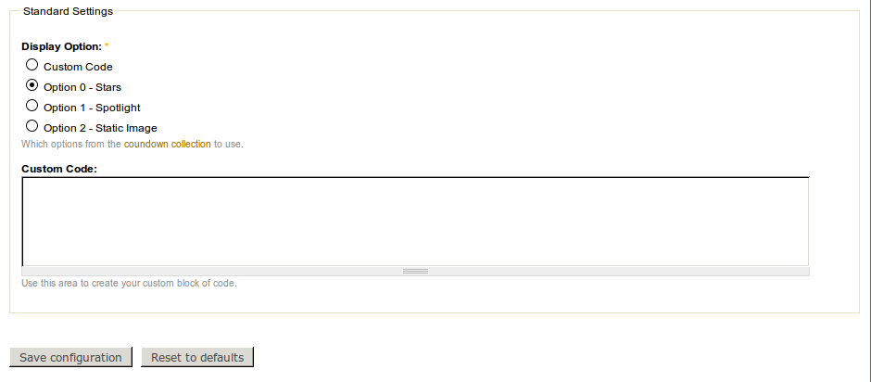

The defaults will work. If you would like to use the second option, simply select it and click “Save Configuration.”

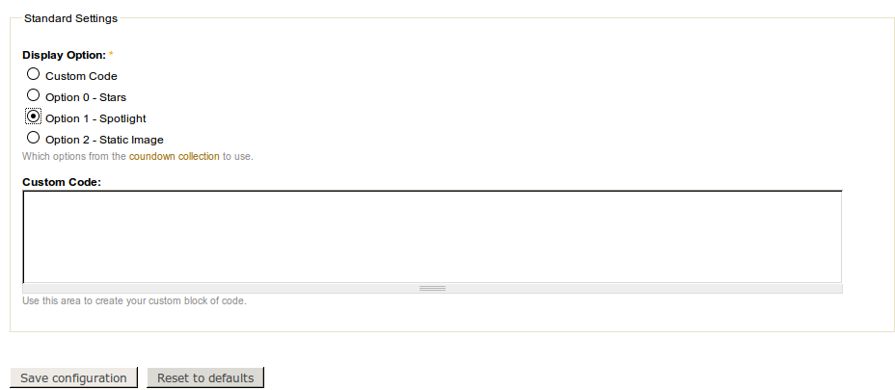
You will then have a message telling you the settings were applied.

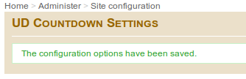

These options are update on a Cron. This is run when you go to yoursite.com/cron.php. Drupal explains how to configure this to run automatically.

Configure the Block
To configure the block so id displays on your site, go to the “Administration” page and click the “Blocks” link in the “Site Building” section.

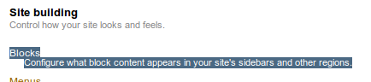

Find the “Ubuntu Release Countdown” block. Select the drop down box to the right of it that currently says “None” and select a region for it. For the example, we will use the “Left Sidebar” region.

You will see the module was moved into this section (region). You can use the handle to adjust its exact location.

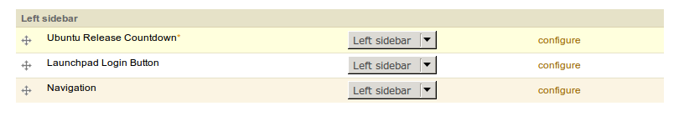
Scroll down to the bottom and click “Save Configuration.” After this saves, go to your front page.

You will now see the block content displayed where you assigned it.

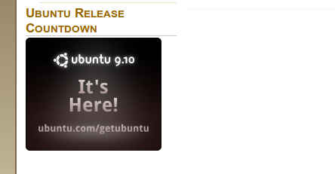

Permissions
This module has permission settings just like any other module. To get to these permissions, go to the “Administration” page and click the “Permissions” link.

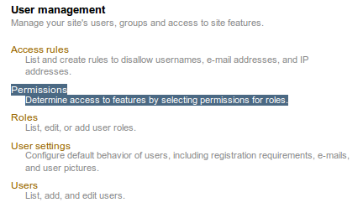

This page is well constructed and well documented in other places. This guide has an example of a basic set of permissions. You can copy these, click “Save Permissions” and tweak as you please.



