Ubuntu Drupal

Setup Guide: UD Header

Table of Contents
Installation 3
Configuration 5
Add Header 6
Edit / Delete Header 8
Configure the Block 9
Permissions 10

Installation
To install the module, I will assume you already followed the UD Theme installation guide. From the front page click “Administer.”

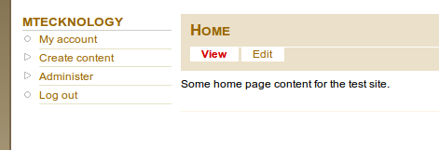

In the “Site Building” section click “Modules.”

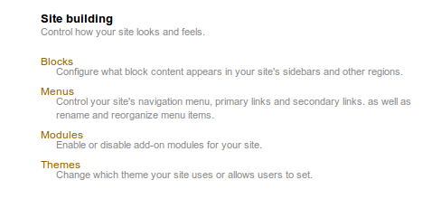

You will then be looking at the modules page.

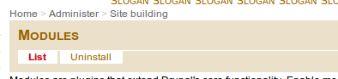

Scroll down to the bottom of the page to see the “Ubuntu Drupal” group of modules.

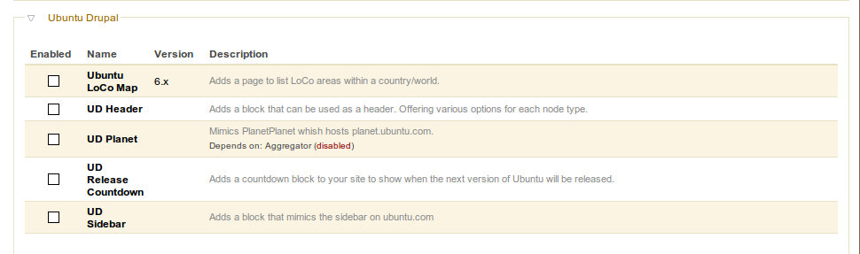

Select the “UD Header” module and click “Save Configuration.”

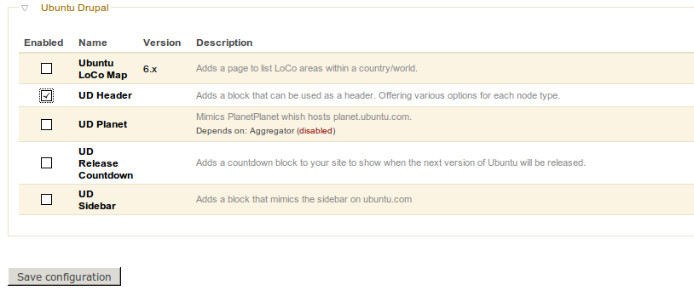

Configuration
Go to the “Administration” page.

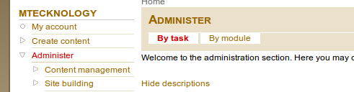

Click the “UD Header Settings” link.

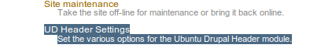

You will see the header maps as well as a section to add header mappings.

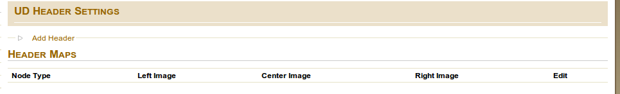

Add Header
To add a header mapping, follow the above and expand the “Header” section.

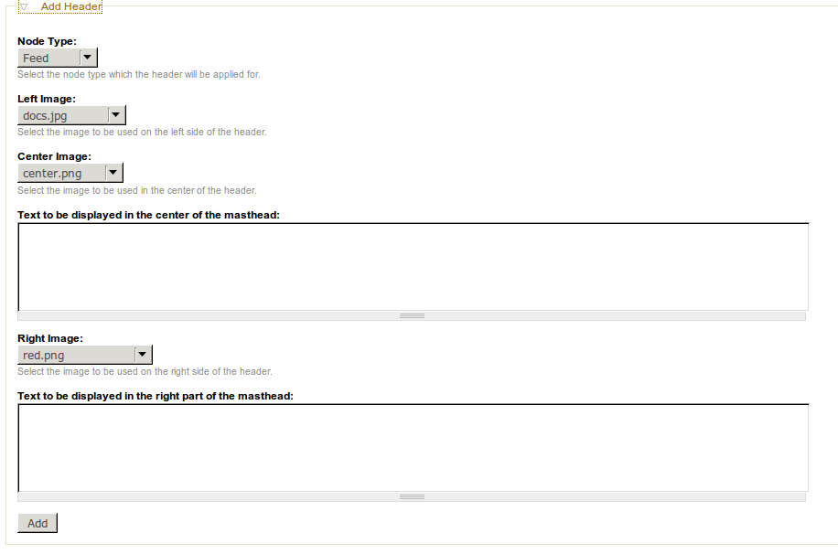

The following is just an example of some content. After filling in information, just click “Add.”

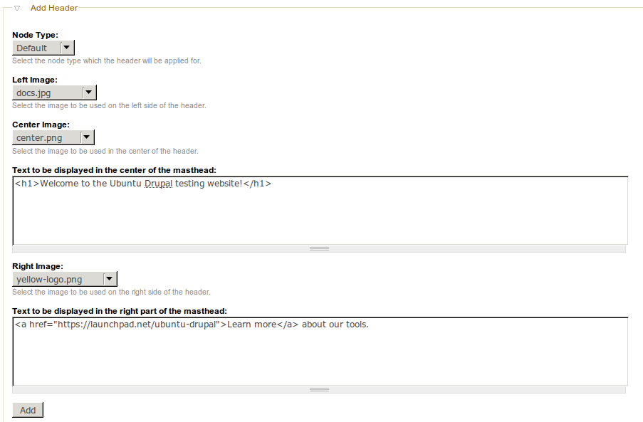

Edit / Delete Header
To alter a header mapping, click the “edit” link to the right of the mapping you want to edit.

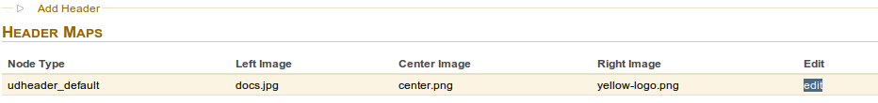
If you want to make changes, you can make them and click Update. If you want to delete the box, click Delete.

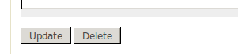

Configure the Block
To configure the block so id displays on your site, go to the “Administration” page and click the “Blocks” link in the “Site Building” section.

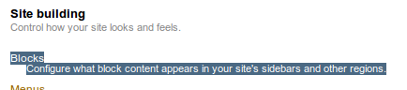

Find the “Ubuntu Drupal Header” block. Select the drop down box to the right of it that currently says “None” and select a region for it. For the example, we will use the “Header” region.

You will see the module was moved into this section (region). You can use the handle to adjust its exact location.

Scroll down to the bottom and click “Save Configuration.” After this saves, go to your front page.
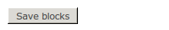

You will now see the block content displayed where you assigned it.

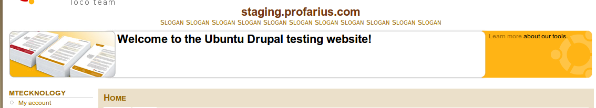

Permissions
This module has permission settings just like any other module. To get to these permissions, go to the “Administration” page and click the “Permissions” link.

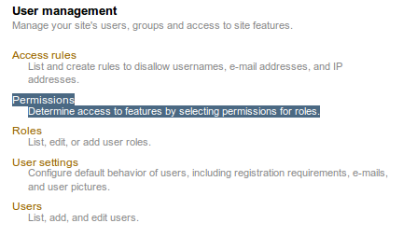

This page is well constructed and well documented in other places. This guide has an example of a basic set of permissions. You can copy these, click “Save Permissions” and tweak as you please.



