Ubuntu Drupal

Setup Guide: UD Sidebar

Table of Contents
Installation 3
Configuration 5
General Settings 6
Sidebar Settings 6
User Settings 7
User Pictures 7
Feed Pictures 8
Managing All Feeds 9
Add User Feeds 10
Edit / Delete User Feeds 11
Users (Managing Own Feeds) 12
Personal Picture 13
Add (Own) Feeds 14
Edit / Delete (Own) Feeds 15
Configure the Block 16
Permissions 18

Installation
To install the module, I will assume you already followed the UD Theme installation guide. From the front page click “Administer.”

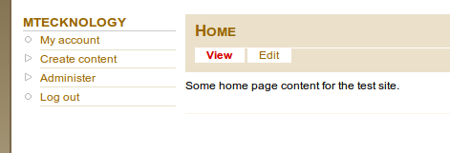

In the “Site Building” section click “Modules.”

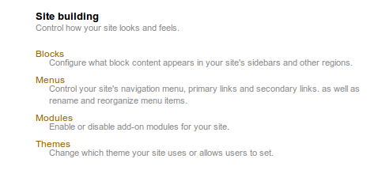

You will then be looking at the modules page.

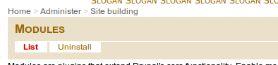

Scroll down to the bottom of the page to see the “Ubuntu Drupal” group of modules.

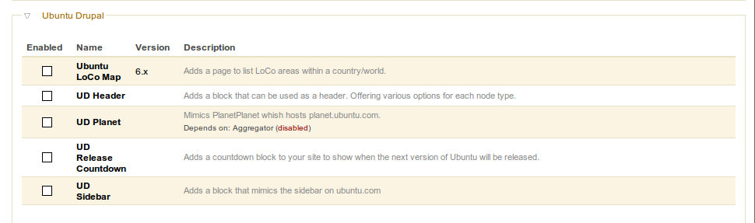

Select the “UD Planet” module and click “Save Configuration.”

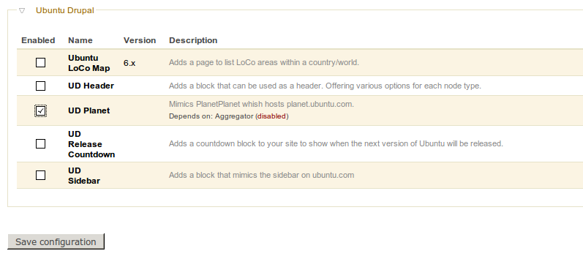
You will be asked to enable the Aggregator module as well.
NOTE: If you are using the Aggregator module for any other purpose, you SHOULD NOT accept this. This module will take full control over the Aggregator module.

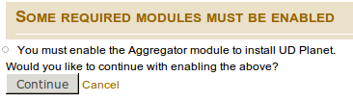

Configuration
Go to the “Administration” page.

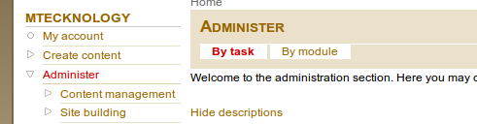

Click the “UD Planet Settings” link.

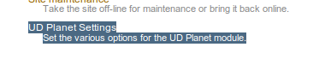

You will see the options for the Planet module. Each section has various options below it. It is likely that defaults will work just fine here.

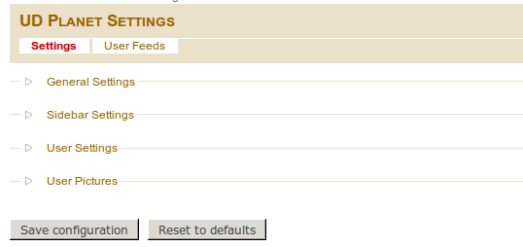

General Settings
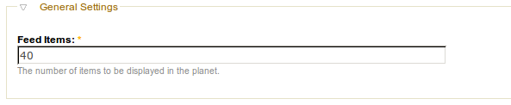
Feed Items: The number of feeds to be displayed on the Planet page. This is likely the only setting you will need to worry about setting. The Planet will consist of a single page, so this is the total number of feeds the user will see.

Sidebar Settings
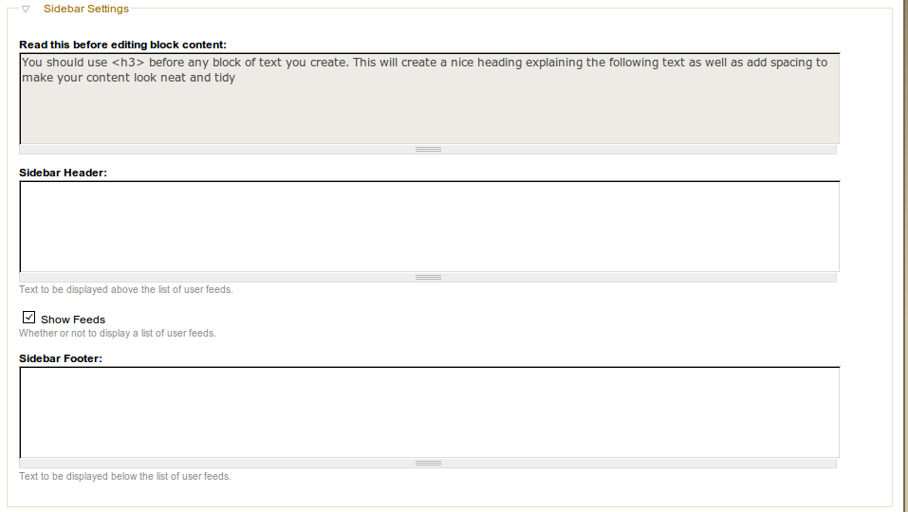
The first block here is just a note. All it's saying is that you should use <h3> for headings because there are CSS rules attached to add shadows and other pretty text effects.

Sidebar Header: This is just text that will be displayed above the list of all user feeds.

Show Feeds: This will display a list of all the user feeds. This will be the title of the feed with a link to the feed source.

Sidebar Footer: This is just text that will be displayed below the list of all user feeds. If you're not displaying user feeds, this section is pointless.

User Settings
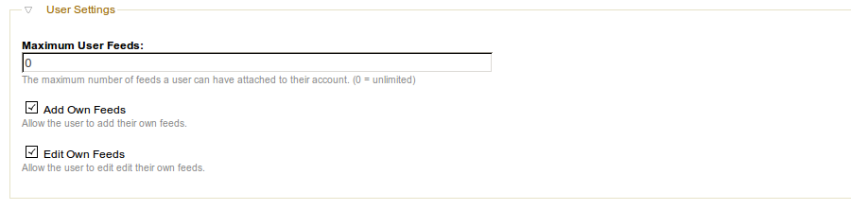
Maximum User Feeds: This is the maximum number of feeds a user is permitted to have.
- If this is set to 0, they will be able to have an unlimited number of feeds.
- If they are below the maximum number of feeds, they can add/delete/update their feeds.
- If they are at the maximum number of feeds, they will be able to update and delete feeds, but not add any.
- If they are above the maximum number of feeds, they will only be able to delete feeds.

Add Own Feeds: If this is checked (default) the user will be able to add their own feeds. This should always remain checked unless there are issues that need to be addressed immediately.

Edit Own Feeds: If this is checked (default) the user will be able to edit their own feeds. This should always remain checked unless there are issues that need to be addressed immediately.

User Pictures

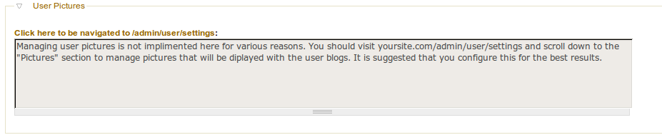
This note explains itself pretty well. This module uses the built in Drupal method for user images. For a user to be able to upload their own images, this option must first be enabled. This is not managed through this module due to complexity requirements.

The title forms a link to a page where you can click to get to the user settings page.

Feed Pictures
Pictures are assigned per user using the Drupal system. To manage this you need to go to yoursite.com/admin/user/settings.

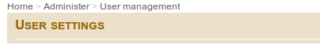

When you reach this, scroll down to the bottom of the page. You will then see where you can enabled picture support. Just choose “Enabled.”
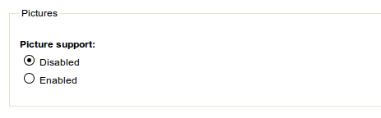

You will then be presented with a list of options you can set for these pictures.
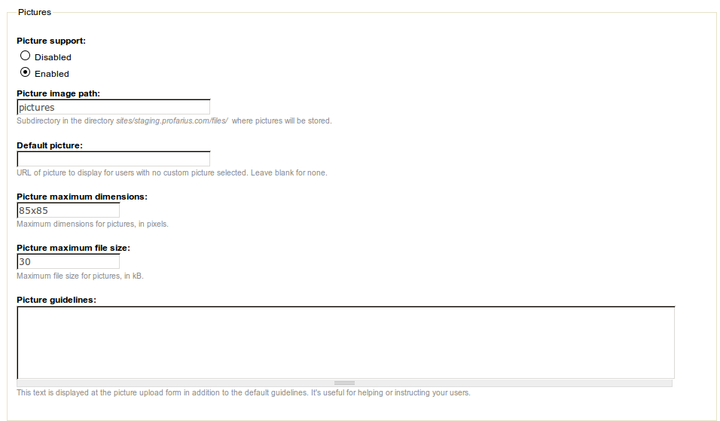
The only thing you will need to be worried about here is the Default Picture.
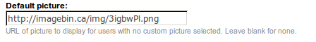

After setting this, click “Save Configuration” at the bottom of the page.

Managing All Feeds
From the “Administration” page click the “UD Planet Settings” link.

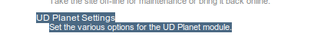

You can then click the “User Feeds” link to manage all user feeds.

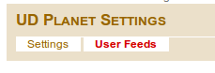

In this section you will see all user feeds as well as the settings applied to it.

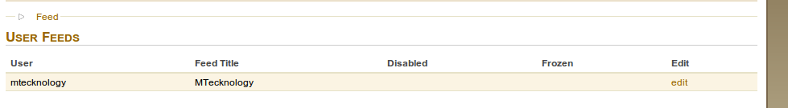
User: The user the feed is assigned to.
Feed Title: The title displayed next to the feed underneath the user picture.
Disabled: Whether or not the feed is shown in the Planet. If the user is permitted to edit feeds, they can also change this setting.
Frozen: This does the same thing as Frozen except that the user is never able to manage this setting.
Edit: This link allows you to edit the feed.

Add User Feeds
Adding user feeds as an administrator should be avoided whenever possible. It's best to have users do this themselves because it is less prone to error.

To add the feed, click the Feed link and the section will expand.

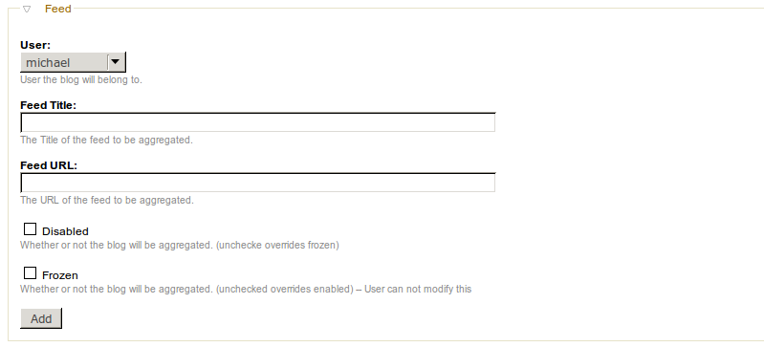
The particular purpose of each setting is described in the “Managing All Feeds” section of this guide.

Fill in the information and click Add.

Edit / Delete User Feeds
Administrators should be careful with this option. This is not reversible.

To edit or delete the feed, click “edit” to the right of the feed you want to manage.

You can then change the information and click “Update.” If you want to delete the feed, you can just click “Delete.”

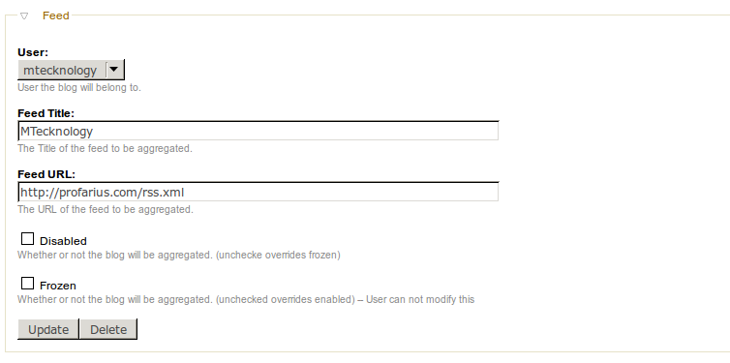

Users (Managing Own Feeds)

As a user, all your Planet management is done from the “My Account” section. When you're logged in, you will see a section called “My Account.”

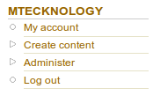

Users should note that an administrator can choose to disable the ability to use personal pictures, add feeds, or edit/delete own feeds. The administrator can also choose to adjust the maximum number of allowed feeds.

Personal Picture
From “My Account” click the “Edit” tab.

Scroll down to the “Picture” section. Choose an image to upload.

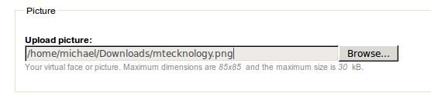
Click “Save” and your image will be uploaded and used with your account.
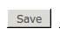

You can also check the “Delete Picture” checkbox and click “Save” to remove this picture from your account.

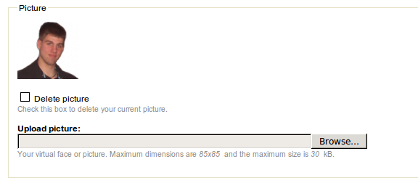

Add (Own) Feeds
From the “My Account” section click the “Planet Feeds” link.
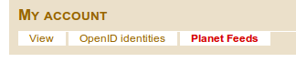

Click “Feed.”

This will open the Add Feed section.

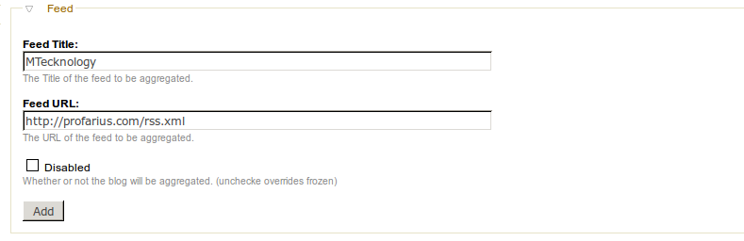
The “Feed Title” is the title that will be displayed under your user picture.

The “Feed URL” is the URL that will be used to aggregate your content.

“Disabled” is used when you want to hide your feed content for a short time.

If your feed is “Frozen” this means the administrator has placed a block on your content. Only an administrator can remove this block.

When finished, click the “Add” button and your feed will now be available for aggregation.

Edit / Delete (Own) Feeds
From the “My Account” section click the “Planet Feeds” link.

Click the “edit” link to the right of the feed you want to manage.

You will then be given the ability to Edit or Delete the feed.

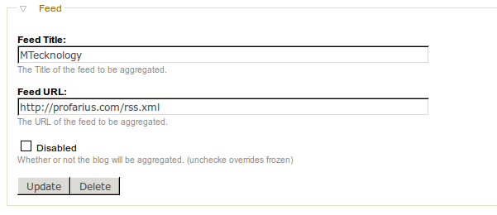
To edit the feed, change the information and click “Update.” If you want to delete the feed, click “Delete.”

Configure the Block
To configure the block so id displays on your site, go to the “Administration” page and click the “Blocks” link in the “Site Building” section.

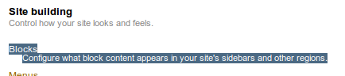

Find the “Planet Sidebar” block. Select the drop down box to the right of it that currently says “None” and select a region for it. For the example, we will use the “Left Sidebar” region.

You will see the module was moved into this section (region). You can use the handle to adjust its exact location.

Scroll down to the bottom and click “Save Configuration.” After this saves, go to your front page.
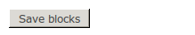

You will now see the block content displayed where you assigned it.

Because this block is relevant only to the page, it is suggested to only display it when the Planet page is open. To do this, click the “configure” link to the right of the “Planet sidebar” block.

Scroll down to the “Page specific visibility settings” page. You will see the following.

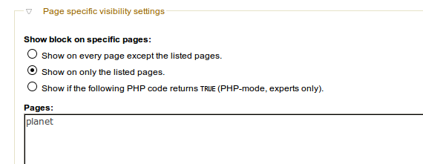

You should choose the above options:
- Show on only the listed pages.
Pages:
planet

Save these settings. Your block will now only appear when the user is viewing the Planet which is exactly where this block is meant to be.

ENJOY!!!

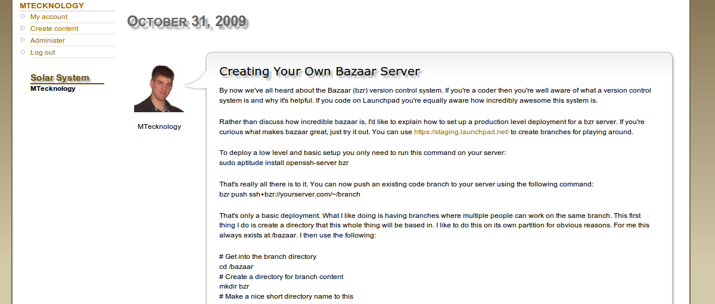

This is a very powerful module considering what it is designed around. Because of it's power, we recognized the need to keep the system flexible. If you would like to see a feature added / removed / modified or have any problems, please do not hesitate to make a request.

Permissions
This module has permission settings just like any other module. To get to these permissions, go to the “Administration” page and click the “Permissions” link.

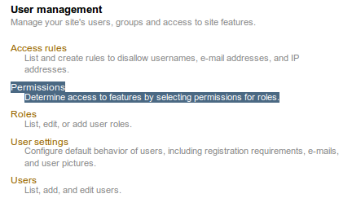

This page is well constructed and well documented in other places. This guide has an example of a basic set of permissions. You can copy these, click “Save Permissions” and tweak as you please.



