Ubuntu Drupal

Setup Guide: UD Theme

Table of Contents
Basics 3
Installation 5
Configuration 6

Basics
It is assumed that you already know how to setup and install Drupal as well as configure basic parts of your installation. We will start at the screen shown below.

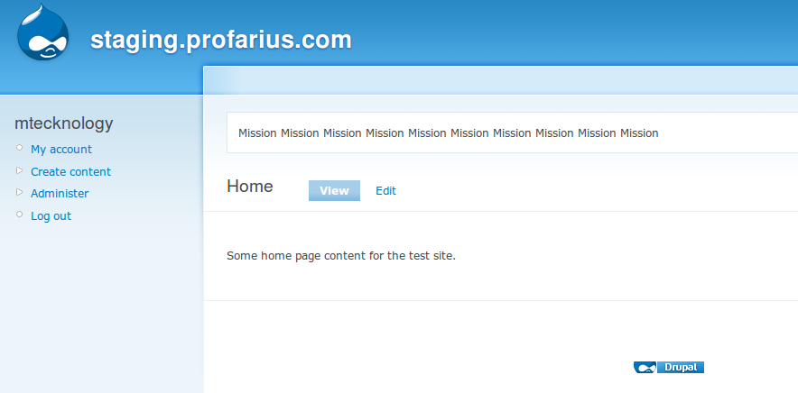
When you click “Administer” you will be brought to the administration page which will look similar to the following image.

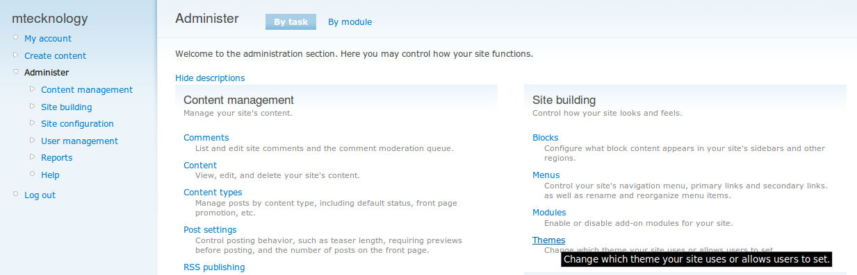
You are concerned with the “Site Building” section right now. Click the “Themes” link to be brought to our next page.

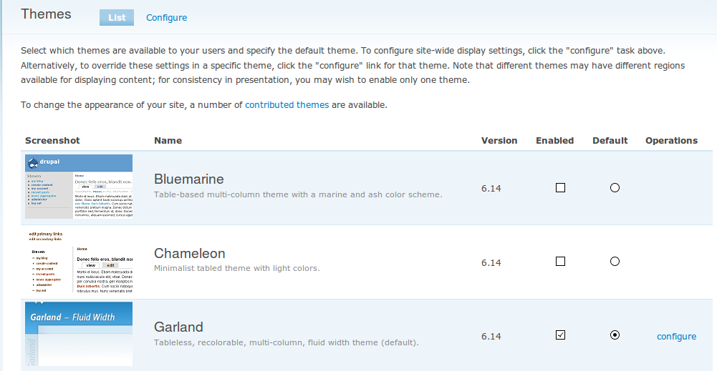
This should look familiar if you played around with Drupal any amount before reading this guide.

Now we're on to installing the theme.

Installation
Scroll down to the bottom of the page and click the “O” to the right of the Ubuntu-Drupal theme. After this click “Save Configuration.”

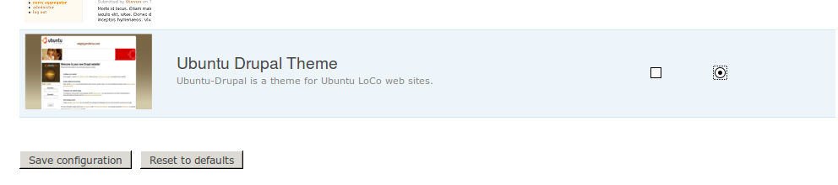
That's all there is to it. You will now be looking at a message telling you that you have successfully installed the theme.

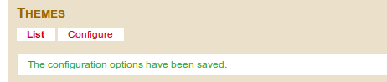

Configuration
Now that you have installed the theme, you will want to configure it. This theme used to have many more options for configuration but these bloated options have since moved into nicer and smaller modules.

Click the “Configure” link at the top of the “Themes” page. You will now see options for your default, previous, and current theme.

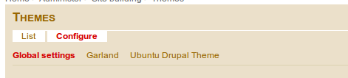

Click “Ubuntu Drupal Theme” and you will see a page similar to the following.

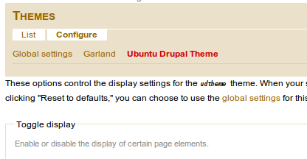

If you scroll down to the bottom, you will see the “Theme Specific Options.” These options apply to this theme only. Although an option does not yet exist to show/hide the breadcrumb, it will exist soon enough.

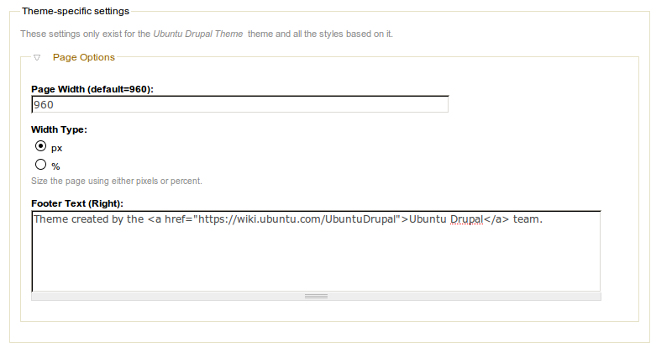
If you'd like to change the width to something like 90%, you can do so with the following.

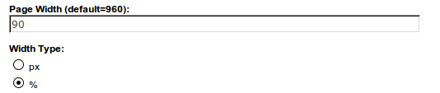

ENJOY!

